**Exercise 1: Relational Database**

Create a relational database container and create and access the case study database.

Open the Cloud Platform Console at [https://console.cloud.google.com](https://console.cloud.google.com/).

Click on the three horizontal bars at the left most side of the blue bar near the top of the browser window. *Select Compute Engine*.

Select *VM Instances*. You should see the virtual machine you created earlier.

Click on the checkbox to the left of the VM name and then select *START*. It will take a few moments to start.

Click on *SSH* to start a terminal window.

**Change the host name to student:** Find the icon that looks like a gear in the upper right-hand corner of this terminal browser window and select *Change Linux User Name*. Enter *student* and *click Change*. Now, notice the prompt that says "student@lab:~$"

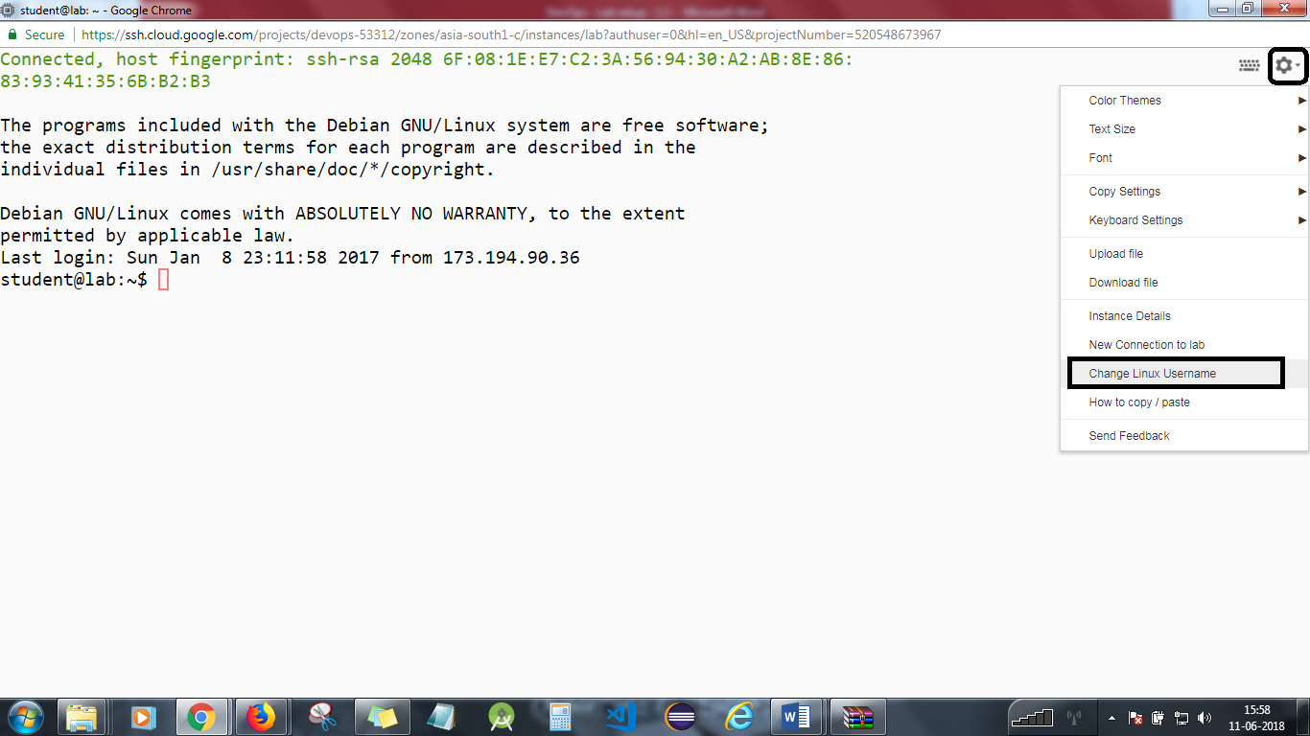

Clone the git repository:

*git clone https://github.com/simplilearn-devops/devops-capstone*

Change to the lab directory.  
*cd  
cd devops-capstone/lab-1*

Create a Docker data volume to hold the database.

*docker volume create --name monitoring_data*

Confirm that the data volume has been created.

*docker volume ls*

provide the access to perform action on the file.

*chmod u+x runserver_first*

Examine the script that will run and create the case study database structure.

*cat runserver_first*

Now, change the port from 3xxx to 8080. Follow the below steps:

*nano ./runserver_first*

Change the EXTERNAL_PORT AND INTERNAL_PORT to 8080.

Type ctrl+x to exit and select Yes ( Y ) .

Run *./runserver_first*

You should be able to see that connection is up and running at the specific port number.

Run the script to create a container with MySQL running, and create the database.

docker run --name=mysql mysql

You will need to monitor the logs to see when MySQL has completed creating the student database and is waiting for connections. This may take several minutes to complete.

*docker logs mysql*

When you see the following in the logs, you may continue. Run the command until you see.

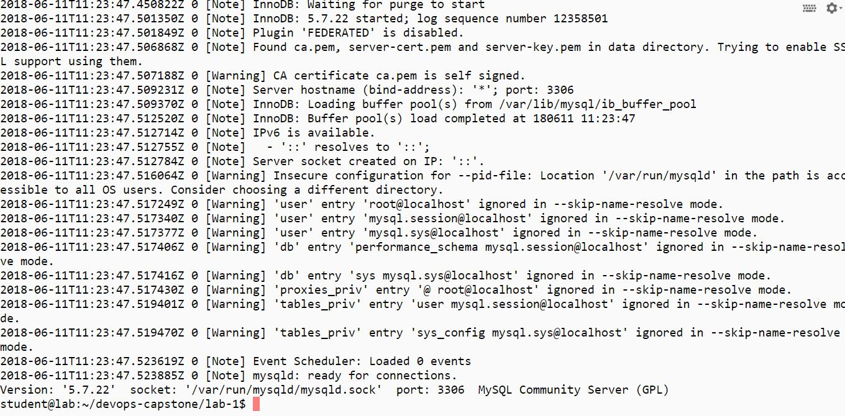

Find the IP address of the server.

*docker inspect mysql*

To run the client and log the data to the database. Follow the steps:

Run *chmod 777 runclient*

Your will be working as at **root** level. You will be placed inside the client container running the Bash command shell. You can now type commands to use the database. You may need to change the IP address to that of the server.

Type *mysql –h 172.17.0.2 –u student –p monitoring*

Password is *student*

When you connect, you will see the MySQL client prompt mysql> as shown below:

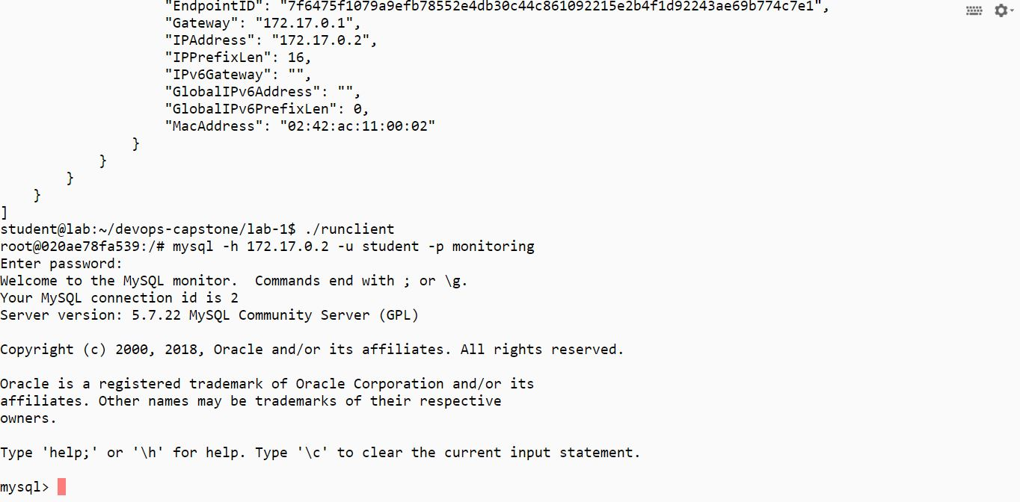

At the prompt, read in the definition for the employee information.

*mysql> source /data/docker.sql;*

Examine the database tables in the database by selecting the first 10 rows from each.

*mysql> show tables;*

Get the content of the Docker table.

*mysql> select * from docker;*

Exit from the MySQL client.

*mysql> quit;*

Exit from the client container.[Please refer to the below screenshot]

*exit*

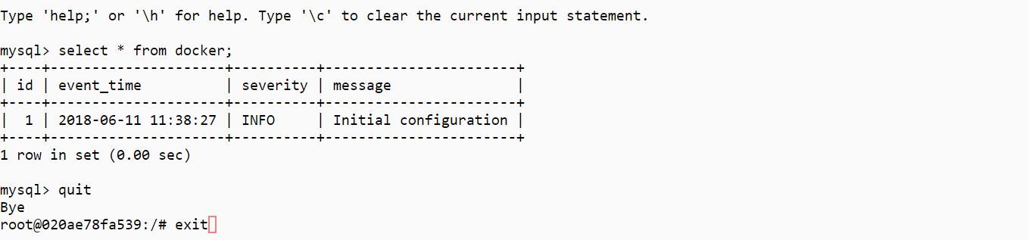

You will need to stop the lab computer at the end of each day to prevent it from accumulating costs during the evening and night.

From the Web UI, you can navigate to the Compute Engine section and select your lab computer. When it is selected, click on the icon representing the "Stop" operation as shown below:

